

Contents

Overall Introduction to Project 2

Product Vision 2

Features 2

Personas 4

What is a Persona? 4

Persona 1 – Angelina, a student 4

Persona 2 – Matthew, a lecturer 5

Persona 3 – Sam, a student 5

Persona 4 – Jennifer, a student 5

Scenarios 6

What is a Scenario? 6

Scenario 1 – Angelina 6

Scenario 2 – Angelina v2 6

Scenario 3 - Matthew 6

Scenario 4 – Sam 7

Scenario 5 – Jennifer 7

User Stories 7

What is a User Story? 7

User Story 1 7

User Story 2 7

User Story 3 8

User Story 4 8

User Story 5 8

User Story 6 8

User Story 7 9

User Story 8 9

Prototype 9

What is a Prototype? 9

Tool used to create Prototype (say if you found it easy to use or not briefly!!!) 9

URL or Screen Shots (not all some) 9

# Overall Introduction to Project

## Product Vision

The target audience of our app is students of SETU.

The name of the application is SETU Cloud, and it is a collection of past exam papers from SETU, ranging from every year and every course with their respective modules in a convenient and easy to use app. It includes features such as a study/remix option which chooses questions from multiple past exams and creates a random new exam to study and revise with. It provides a discussion feature, where students may post questions relating to the module, and other students may be able to reply with help.

The reason to use this application is because it provides an easy to access and convenient source of study material with up-to-date exam papers and useful tools to aid in studying. The current available page, Moodle, has all the exam papers unorganised and uncategorised; some lecturers don’t even know where to find the papers to provide help.

Unlike similar applications, such as StudyClix, the SETU Cloud specifically caters to the attending students. It provides more relevant study material and available aid to students who need it. For example, the application may notify students regarding new material being uploaded, or study groups being set up relating to their current module/modules.

# Features

**Remix mode for exam papers for study**

Description: To take sections of previous exams and merge them together to make a full practise exam paper

Functionality:

● Button to Search

● Search bar

● Text field to search

● Button to remix exams

**All exam papers for every course in SETU**

Description: To make every exam paper from every module available and easily accessible on a single application that is convenient and easy to use

Functionality:

● Button to Search

● Search Bar

● Filter button

● Scroll bar

● Button to view paper

● Button to download paper

**Discussion area to talk about the questions and answers**

Description: A discussion area to talk about topics and methods from each module

Functionality:

● Search bar

● Button to search

● Filter button

● Scroll bar

● Create discussion button

● Delete discussion button

● Text field for the discussion topic and sentences

● List view of all discussion topics

● Create comment button

● Delete comment button

● Reply button

● Choice box for subject when uploading discussion

**Login**

Description: A login system to ensure each user is attending SETU

Functionality:

● Text field

● Register button

● Text field for name

● Text field for email

● Login button

● Forgot password button

**Lecturer emails who teach on certain topics**

Description: a collection of emails for lecturers that teach a certain module

Functionality:

● List views of all lecturers

● Search bar

● Text field for search

● Search button

● View profile button

**Notice board for study groups set up by other students or by SETU themselves**

Description: A notice board providing information for group study sessions, hosted by either other students or lecturers which students interested may join/participate in. The notice board provides time, location and module.

Functionality:

● Search bar

● Text field for search

● List view of all current study groups

● Choice box for module

● Date picker for day and time

● Add button

● Remove button

● Text field for group name

● Scroll bar

● Join button

● Leave button

**Locked to SETU emails only for security reasons (CONSTRAINT)**

Description: The application will be locked to only SETU emails for security reasons. The application will also be linked in the Moodle website, which is also student only.

Functionality:

● Text field to input email addresses

● Email requires “@wit.mail.ie” or “setu.mail.ie”

# Personas

## What is a Persona?

*A persona is an imagined character that is created to portray the different types of users that may use the product to help understand the design features and interface that is suited to a user.*

## Persona 1 – Angelina, a student

Angelina, age 19, is a nursing student in SETU, currently in her 2nd year of studies. She was born in a rural town in South Cork, where her mother worked as a nurse at Cork Hospital, and her father worked as a software engineer in Google. A lot of her friends ended up staying in Cork, resulting in her feeling homesick as she lived in student accommodation and only ever returned on the weekends or holidays. Growing up, she was always inspired by her mother’s job. She is extremely dedicated and motivated with her studies, especially as she wants to impress her mother with her skills. 

Angelina’s dedication to study became a lot harder when she started university, as she struggled finding past exam papers. She hates asking questions in class, so she often avoids asking about the paper’s location. While enjoying attending lectures, she prefers learning the material herself or in study groups. The SETU Cloud application would spike great interest for her, as it would provide easy access to past exam papers, but also the possibility to create or attend study sessions with other fellow students.

## Persona 2 – Matthew, a lecturer

Matthew, 59, is a Physics lecturer at SETU. Originally from London, England, Matthew was always passionate about science. After years of intense study, he graduated from University of Edinburgh with master’s in physics. During his studies, he met his partner who was Irish. After his first child was born, they moved to Waterford, Ireland. He decided to become a lecturer at SETU as he loves to share his knowledge and his passion.

Matthew never was interested in technology, and he never even owned a social media account. He despises the virtual learning environment, so he doesn’t partake in it unless needed to. He believes face-to-face teaching is most effective. While he acknowledges his own opinions about technology, he is also aware that his students may prefer digital tools for learning, so he attempts to accommodate them through email. A lot of students don’t know where to find the email as it was never provided anywhere that is easily accessible. Matthew doesn’t really understand how things work, so all of the exam papers for his module are unorganised but he doesn’t know how to fix it. He may use SETU Cloud as it would provide an easier interface for him to upload and store exam papers, ensuring his students may access them without contacting him, but he would not use any other features as he has no interest in them.

## Persona 3 – Sam, a student

Sam is a 21-year-old accounting student at SETU. He is currently in his 1st year. He was born in Clonmel and decided to study in Waterford mainly due to the social scene, as he enjoys partying at night. He plays at his local soccer team and plays video games with his friends. His mother is a caregiver at a retirement home, and his dad works as a truck driver. He has a very laid-back attitude. He doesn’t really care much about his grades and studies, so he rarely attends any classes and only puts in effort when needed. Regarding exams, he often struggles with his lack of preparation and tries to cram information into his head before the exam itself. 

SETU Cloud may be essential to Sam as he tries to pass his important exams. He wouldn’t be an active, engaging user but rather using it for quick access. He might also use the discussion feature but is more likely to look at existing answers rather than actively post himself. Sam relies more on efficiency and convenience rather than typical study methods, in which he might find SETU Cloud helpful. The application removes having to search for the resources that usually are difficult to find, ensuring Sam has an easier time attempting to prepare for his future exams.

## Persona 4 – Jennifer, a student

Jennifer is an 18-year-old 2nd year Arts student aspiring to be a future secondary school teacher, teaching English and Irish. Her mom is a stay-at-home mom, while her dad is a construction worker. She was born in Dublin and has lived there her entire life until she decided to study at SETU. She was an average student but always excelled in Irish. Over the last 3 years, she has been learning Spanish privately. In her second year, she is currently studying English and Irish. She is also a perfectionist, who is obsessed with stationery and planning. All of her studies and daily routines are previously planned out. She would love for a place to be able to find more fellow students like her who have a passion for learning language. 

Jennifer may find SETU Cloud’s study group feature useful as she will be able to find students who are currently studying the same thing as her, and she is able to make new friends a lot easier because they will all have similar interests. Hopefully, this will give her an opportunity to expand her social life while also doing what she loves.

# Scenarios

## What is a Scenario?

*A scenario is an imagined narrative that describes how a user or a group of users may interact with the system.*

## Scenario 1 – Angelina

Angelina, A 2nd year nursing student at SETU is planning to revise the content of her course throughout the year to keep on top of her studies. However, due to limited or inaccessible notes and exam papers provided by the lecturers, she is unable to find enough content. With the use of the SETU Cloud app, Angelina can find past exam papers and notes easily, which are organised by modules and year, provided by lecturers and students. This wide availability of notes and papers allow Angelina to study effectively and remain confident for the upcoming tests, reports and exams.

## Scenario 2 – Angelina v2

Angelina is going to have her final exams in the next few weeks, and she is planning to start studying, but she quickly realised that she is struggling to understand some of the notes by herself. Usually, Angelina and her friends study together as a group efficiently, but as the exams are upcoming, everyone’s schedule becomes a lot busier. However, due to the SETU Cloud app, she is able to find or set up study groups with other students, allowing her and her classmates to cooperate and go through the notes together to prepare for the final exams.

## Scenario 3 - Matthew

Matthew, a SETU lecturer from London, decided to do a small in class test on a topic they have just covered completely. The test will contain all the content within the topic and Matthew is worried for his students due to the amount and complexity of the content covered. Matthew began recommending for his students to start using the SETU Cloud app to find useful notes and past papers on the topic, so they can be more prepared and aware of what may come up. Due to the extensive number of notes and exam papers uploaded by previous students and lecturers, Matthew was relieved, and his students were able to prepare efficiently in their own time.

## Scenario 4 – Sam

Sam, a first-year student at SETU, tends to avoid studying as he prefers to spend his time out in the Waterford social scene. Due to his usual lack of studying, Sam struggles with his exams and projects. He realised he has a lot to revise, but he simply isn’t bothered. Sam discovered the SETU Cloud app, and started using the remix mode to provide quick and engaging study he can do in his free time. Sam tries to use the app between classes, events or travelling to/from college whenever he remembers.

Another feature of the SETU study application to aid Sam in his studies is the daily challenge mode. The daily challenge mode gives students a small problem related to their course and the most accurate and fastest answers are ranked on a leaderboard. This mode utilises Sam's competitive nature to entice him to study daily and engage in his course despite his lack of enthusiasm for studying.

## Scenario 5 – Jennifer

Jennifer, a second-year student of SETU, is a massive fan of languages. Proficient in English, Irish and Spanish, Jennifer wishes to find people to practise and learn more international languages with. However, she struggles finding people who do wish to learn the same languages as her. With the help of the SETU study application’s community chat and study group features, she is able to find other like-minded students to learn and speak multiple languages with, aiding her to master the languages she wishes to study.

# User Stories

## What is a User Story?

*User stories are short narratives that set out a direct description of what a user would like to do with the product. They are written from the user’s perspective, describing which features they would like.*

## User Story 1

**As a student looking to find new friends to study with, I want:**

● To be able to find study groups with my modules so I can work with other people

● To find new people with common interests so I can stay motivated

● To create my own study group and let others joins

● To receive reminders/notifications of when a study group will happen so I can join in whenever

● To share answers or questions with other people to see different perspectives

## User Story 2

**As a lecturer, I want:**

● To be able to provide the best possible notes to my students

● To provide accurate information on tests and examinations such as dates and locations to provide the educational support a student may need

● To be able to access past exam papers to use for tutorial classes to help students understand the formatting and questions asked

● To upload extra resources and materials for students who are curious more about the module

## User Story 3

**As a student who studies often, I want:**

● To be able to easily access the past exam papers to prepare better for exams

● To be able to study at any time I wish whether it is a lot of time or a few minutes, to keep on top of my studies

● To be able to randomise the questions to check my knowledge of the topic

● To download any material so I have it available in case internet is not working

● A way to filter which year and module I wish to study

## User Story 4

**As a student who struggles with education and may need extra help, I want:**

● A place where lecturers email or contact information is found easily in case, I don’t understand something or need extra help

● Easy access to study groups to be able to learn more from people around me

● To receive notifications when new work is uploaded

● To have a choice to enable notifications for due dates so I know when things are due, making time management easier for me

● To be able to see past exam answers to possibly prepare myself more for the future

## User Story 5

**As an administrator on the staff team, I want:**

● To ensure each student using the application has a valid student ID and email, ensuring all the members are a real student at the university

● To be able to edit, manage and view all comments and study groups created

● To assure everything uploaded is appropriate and be able to delete it otherwise

● To be able to contact lecturer’s easily, view their activity and notes, ensuring the lecturer is using the application in the right way, and provide support to struggling ones

● To receive feedback and reviews of the applications so I know what can be improved

● To be able to freeze and remove/ban individuals or accounts that are misbehaving to create a friendly environment for everyone

## User Story 6

**As a lecturer that doesn’t use much technology, I want:**

● An easy-to-understand interface so I don’t have to go out of my way trying to figure it out

● A technical support or some sort of support to help me understand features I don’t get

● To upload the best quality notes without a lot of effort

● To be able to inform of my absence in a place where most who would care would see

● To see the discussions amongst classmates to see if there is anything that should be covered in class

● To be able to schedule extra study sessions for students who need more support or have any questions

● My students to be able to message me or find my email quicker so I can spend more time teaching

## User Story 7

**As a student representative, I want:**

● To be able to view and attend study groups to gather any feedback so I can help struggling students connect with support

● To create discussions and polls to gather feedback about their academic concerns

● To be able to communicate with lecturers and administrators directly so I can discuss student concerns

● To be able to be easily found by other students in case they want to contact me regarding any issues

## User Story 8

**As a part-time student, I want:**

● To be able to access notes from lecturers so that I can still be on top of my work and still balance my work/family life

● To receive reminders on important class tests and due dates so I can make sure nothing is forgotten while I am not on campus

● To have a place where I can discuss topics with other students so I can still stay connected while off campus

# Prototype

## What is a Prototype?

*A prototype is an early sample or model of a product to be able to test concepts, processes and design.*

## Tool used to create Prototype (say if you found it easy to use or not briefly!!!)

To be able to create a prototype of our application, [Uizard.io](http://app.uizard.io) was used. It wasn’t overly difficult to use, and pretty self explanatory. Any troubles relating to the prototype mainly came from deciding how we wished for it to look like, such as the themes and layout. Overall, it was fun to design and pretty easy.

## URL or Screen Shots (not all some)

Home Screen Login Screen

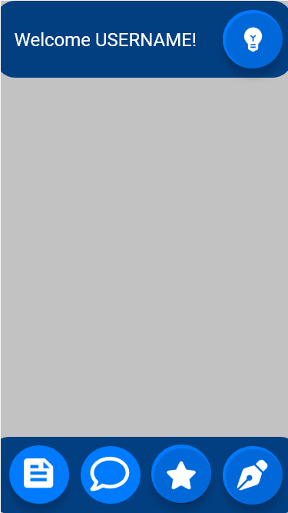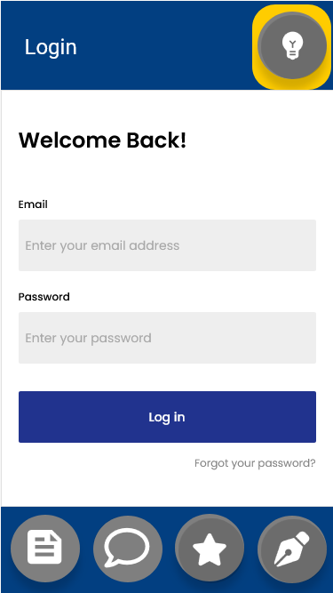

Settings Screen Group chat Screen

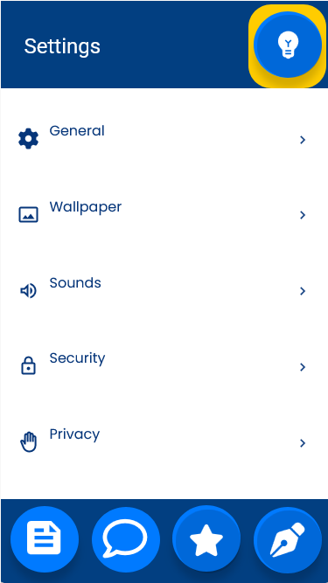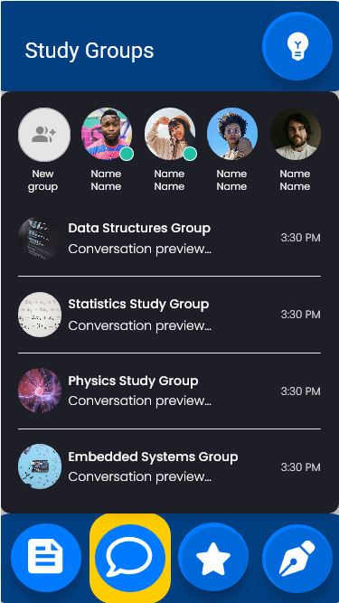

Lecturer Contact Screen Exam Papers Screen

